Leave Your Leaves
8th Grade Lesson 1, 2, 3 Plans and Activities
Lessons for Middle Schoolers on the ecological benefits of letting leaves stay on the ground as they fall in our communities. These activities below are designed to be done in classrooms as well as outside on school grounds where available. Lessons are about one hour, but each one indicates how to shorten or lengthen the lesson as your time dictates. Minimal supplies are needed, and are listed at the beginning of each lesson along with alternative options.
Background: Leave Your Leaves Background from Audubon Society

NC Science Standards Covered

8th: 8.E.1 Understand the hydrosphere and the impact of humans on local systems and the effects of the hydrosphere on humans.
8E.1.4 Conclude that the good health of humans requires: Monitoring of the hydrosphere Water quality standards Methods of water treatment Maintaining safe water quality Stewardship

Understand the structure and hazards caused by agents of disease that effect living organisms.
      - Summarize the basic characteristics of viruses, bacteria, fungi and parasites relating to the spread, treatment and prevention of disease.

Understand how organisms interact with and respond to the biotic and abiotic components of their environment.
      - Explain how factors such as food, water, shelter, and space affect populations in an ecosystem. 8.L.3.2 Summarize the relationships among producers, consumers, and decomposers including the positive and negative consequences of such interactions including: coexistence and cooperation competition (predator/prey) parasitism mutualism
8.L.3.3 Explain how the flow of energy within food webs is interconnected with the cycling of matter (including water, nitrogen, carbon dioxide, and oxygen).

8th Grade Lessons

Grade | Lesson 1 | Lesson 2 | Lesson 3:  Community Education
8th Grade | Leave the Leaves to protect the Watershed: Watershed Model | Leave the Leaves as Erosion Prevention: Leaves Slow the Flow | Teach the Community to Leave the Leaves: Leave the Leaves Infographic

8th Grade Lesson #1:
Lesson Plan Time: 45 mins- 1.5 hours depending on how long you have!
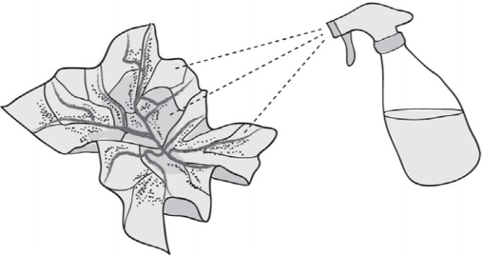

Background Information: Erosion and weathering of our river banks and riparian zones causes an increase of sediment in our rivers. In this activity students watch water flow through a watershed model and then add model plants and leaves to see the water slow.

Materials:
      - Butcher paper
      - Washable markers of any size
      - A spray bottle (more spray bottles will make it easier)
      - Pen/pencil and copies per student of this Watershed worksheet
      - Access to this website or information about preventing erosion.

Objectives: 8.E.1 Understand the hydrosphere and the impact of humans on local systems and the effects of the hydrosphere on humans.
8E.1.4 Conclude that the good health of humans requires: Monitoring of the hydrosphere Water quality standards Methods of water treatment Maintaining safe water quality Stewardship

Summary: Students will design a village around several creeks and a river. They will then watch water flow through their village in the form of rain sprayed onto their paper.

Vocabulary: watershed, weather, erosion, sediment, pollution

Lesson Steps:
- Have students explore the topographic map of where they live. Durham topo maps, and others can be found here. Discuss map components and how to read the map.
- Students will now create their own town and create a 3D topo map of their area.
- Hand out the steps worksheet which, like below, detail how to create their town.
- Crumble a piece of butcher paper into a ball.
- Gently open the paper, but don’t flatten it out completely, just open it so it looks like a mountainous area.
- The highest points on the paper now represent mountains and the lowest wrinkles represent the valleys where there are streams and rivers. Have students name their town.
- Choose one color of the water soluble markers to trace the highest points on the paper (or “map”). These are the mountain ridge lines.
- Choose a second color to trace the places where different bodies of water might be, such as streams, rivers, ponds, lakes, etc.
- Use the third marker color to mark several places to represent human settlement, such as housing, factories, farms, schools, shopping centers, etc. Label each spot.
- Have students choose the biggest, lowest crease to be their main river. Name their river and make predictions about how water will flow through their town.
- Use a spray bottle to gently mist each finished map. This represents rain falling onto the watershed.
- Discuss any observations about how the water travels through the watershed area.
- Explore information about reducing this weathering and erosion represented by the mixing colors using the resources provided, or your own.
- Repeat this activity, giving students small bits of leaf litter (or sponges if you can’t access leaf litter) to use strategically in their models.
- Lastly students write a concluding statement with the help of sentence starters.
Other Resources used in planning this lesson:
https://omsi.edu/sites/all/FTP/files/expeditionnw/4.E.1.Crumple.pdf
8th Grade Lesson #2: Leaves Slow the Flow
Lesson Plan Time: 45 mins- 2.5 hours depending on if you choose to make the models together, demonstrate it yourself or just use the video. You also could skip the claim, evidence reasoning summary activity at the end.

Background Information: Weathering and erosion of unprotected sediment is the greatest polluter to our rivers and streams. Extra sediment smothers living organisms, clogs gills and limits flora and fauna reproduction. Leaving leaves on the ground helps to keep soil from eroding and moving into our waterways.
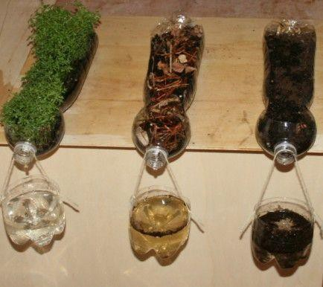

Materials:
  - For building the erosion models you will need the materials listed in the instructions.
  - Student Worksheet (1 sheet–printed front and back)

Objectives:
    - Understand the hydrosphere and the impact of humans on local systems and the effects of the hydrosphere on humans.
8E.1.4 Conclude that the good health of humans requires: Monitoring of the hydrosphere Water quality standards Methods of water treatment Maintaining safe water quality Stewardship

Summary: Students observe or create and observe, three erosion models to conclude that plants and leaves help keep our water sources clean. Next they analyze data and investigate the health of their local waterways. They conclude by writing “Claim, Evidence and Reasoning” statements about how leaving the leaves protects their waterways.

Vocabulary: Turbidity, Soil Horizon, Erosion, Claim, Evidence and Reasoning

Lesson Steps:
      - Begin by showing (in class demo, together or as a video) or creating these erosion
models. This can take a varying amount of time depending on your needs.
      - The students record their observations on the student worksheet.
      - Lastly, students will write a claim, evidence and reasoning to answer the question: “How do we reduce erosion into our waterways and keep turbidity low?” If this way of writing to share information is new, you can use this mini lesson. The back of the student worksheet includes the example from the mini lesson and sentence starters for the claim, evidence and reasoning.

Extension idea: Explore turbidity on graphs pre and post storm events.
https://www.lakesuperiorstreams.org/streams/tischeranimation.html You could extend to discuss effluent with this graph:
https://www.lakesuperiorstreams.org/streams/images/graphs/animations/wlssd2003.gif Also, you can check out the health of your loc al waterways here:
https://www.epa.gov/waterdata/hows-my-waterway

8th Grade Lesson #3: Teach the Community to Leave the Leaves
Lesson Plan Time: 1-2 hours depending on how long you have!

Background Information: Students should have either completed at least one of the previous 8th grade lessons, or have background about human impact on the hydrosphere. This will help them to already know the main ideas for their infographic.

Materials:
- Leave the Leaves Infographic sheet
- Poster making materials (paper, colored pencils, markers), or you could have students use Google Drawings, or Canva etc to do an online version.
- Internet access and/or printouts and notes from previous lessons

Objectives: 8.E.1 Understand the hydrosphere and the impact of humans on local systems and the effects of the hydrosphere on humans.
8E.1.4 Conclude that the good health of humans requires: Monitoring of the hydrosphere Water quality standards Methods of water treatment Maintaining safe water quality Stewardship

Summary: Students connect their community to the ideas they have learned about in this lesson and the previous two.

Lesson Steps:
- Start with the mini lesson “Ethics in Science” to lay the groundwork for why sharing what we learn is an important part of science. This also will discuss pointers on how to make an effective poster.
- Have students do a Google Image search for Infographics on environmental topics. They can use the keywords: Infographic and then water, or erosion or ‘protect earth.’
- Ask them what they are seeing and gather some common ideas.
- Pass out the Leave the Leaves Infographic sheet.
- Review with students that they are making an informational poster that highlights data using visuals.
- Students can build online in a format they are comfortable with (Google Drive, Canva, Adobe, Drawings, Visual.ly) or they can draw on paper.
- Provide enough time for students to create posters, receive feedback and make edits before hanging these in a public space.
- Display these visuals in a place where other classes wait and can read them.
- You could have a vote on the infographic that is the most impactful, creative, clear, etc.

